Justus - Liebig University
“Teaching to Transgress” and Teaching Diversity with bell hooks
Prof. Dr Margareta Olson
Winter semester 2022/2023

Meditating on practices of resistance as litanies for survival.

Kemelo Sehlapelo
01/04/2023

“When education is not liberating, the dream of the oppressed is to become the oppressor.” – Paula Freire
This is a quote by Brazilian educator and philosopher Paulo Freire. It captures the essence of what it means to “teach to transgress”. To teach and educate with the aim of encouraging a spirit of liberation. A pedagogy that transcends the confines of structural barriers and instead, recognises the inherent curiosity of imagining a different world.

Personal Reflections
I did not have many expectations when signing up for this seminar. Apart from seeing excerpts of bell hooks’ teaching on curated visual content on Instagram, I had not been familiar with her teachings. While I did not know so much about her and her work before this seminar, I always felt a strong connection to any quote of hers that I read. Taking this seminar provided me with the opportunity to dedicate the time and space to explore hooks’ work on a deeper level – one that I resonated with and that became a source of comfort, a blanket of assurance and validation. Artistically, hook’s work has become a source of reference in my practice. I am particularly drawn to her ideas on what can be described as experiential knowledge:
“Knowledge rooted in experience shapes what we value and as a consequence how we know what we know as well as how we use what we know.” (hooks, 2007)
I found that it relates to the notion of situated knowledges, a term coined by Donna Haraway in her 1988 essay “Situated Knowledges: The Science Question in Feminism and the Privilege of the Partial Perspective”. I am in interested in the centring of personal narrative that these ideas acknowledge. That there is a necessity to acknowledge the intersectionality of identity and history in academic discourse, rejecting the notion that personal experience and subjectivity do not belong in said discourse.
Similarly, I have chosen to present what I have taken from the various readings and teachings of hooks in this seminar as a visual journal. I will include my meditations and anecdotes on her teachings, and reference experiences from a South African context.

Talking Back
What do these three pieces of writing have in common, other than the fact that they are written by the same author? For one, they situate around the lived experience of Black girlhood and womanhood. A theme that is central to hooks’ work is that she seeks to interrogate the notion of the “neutral-sounding academic voice” which lacks any personal and emotional tone. A tone that, in seeking to bear witness to a generational struggle of resistance, is often deemed “too personal”. In the preface, introduction and first essay of Talking Back, hooks’ writes in remembrance and reminiscence of her childhood. To be a black girl was to be in a state of confusion; not knowing whether to speak in defence of oneself or others for fear of punishment. To be a black girl child was to doubt herself and her experiences; to make them small or better yet, to forget or dismiss them entirely. It was to carry a shame that was not yours. A shame that was inherited and shaped through various intersections of oppression.
Using practices of resistance can be a powerful tool to overcome the sensation of being silenced in the face of oppression. hooks’ meditates on writing as her practice of resistance, a way to navigate the “pain of fragmentation”:
“…writing to bear witness to the primacy of resistance struggle in any situation of domination (even within family life), to the strength and power that emerges from sustained resistance and the conviction that these forces can be healing and protective.” (hooks, bell 2015 [1989]).
Resistance has taken many forms throughout history. Storytelling in particular is a practice that has greatly contributed to different societies’ collective memory of many significant events. Storytelling is an imaginative way that oppressed people resist what hooks’ describes as “a struggle of memory against forgetting”. A few examples come to mind, one being the stories my parents, aunts and uncles used to tell us (and occasionally, still do) about what it was like to live life as black people in South Africa during Apartheid. Many of the stories I heard spoke to the experience of doing the things that I did every day without a thought as a child. They spoke to deciding whom to love and how loudly to love, based on whether it was safe to do so. My aunt and uncle often talked about the fragmentary experience of being a part of the “born free”. “Born-frees” is a term used to describe the generation that was born after the country transitioned to democracy. In the South African context, that does not only mean being born post-apartheid but having grown up in the early stages of our democracy as well.
Having to deal with having more privileges than your ancestors, like being allowed to be educated on the same level as white people (having access to prestigious schools and scholarships, for example) and being able to live where you wanted to and even have relationships with whom you want bring a different set of issues to deal with. Similarly, to hooks’, this new experience of integration – especially as black children had to assimilate into an education system that was (and, in many ways, continues to be) dominated by South African whiteness often created a clear distinction between black people and white people, and between the black upper-middle class, upper lower class and black people living in poverty. The pain of fragmentation that hooks’ refers to became more of a phenomenon for born-frees: the split between public and private blackness or, a blackness that was muted for the sake of making space for whiteness in white spaces.
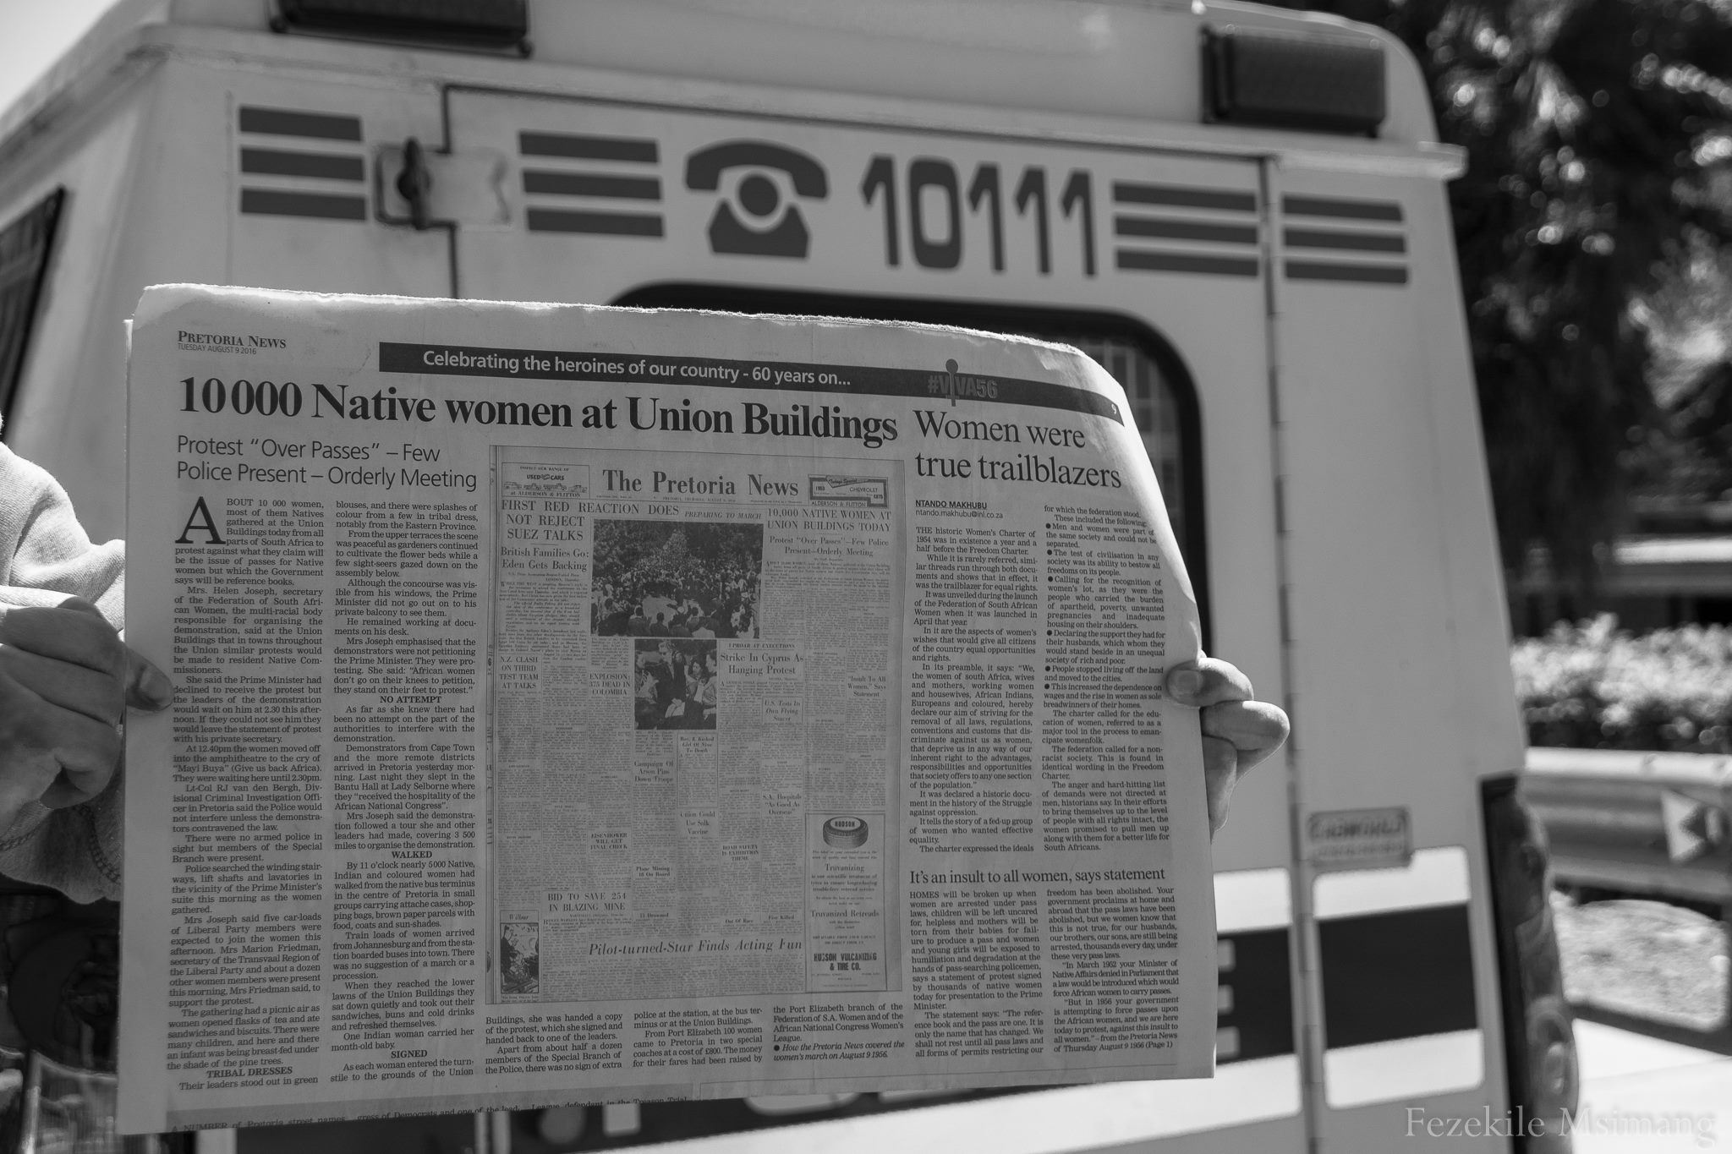
Msimang, Fezekile (2016). Pretoria.

The essence of Talking Back is one of defiance. And when I think about post-apartheid South Africa, I cannot think about the defiant people who put their bodies at the forefront of violence and discrimination in the spirit of liberation. In my country’s history, women and femmes were at the centre of the fight for the liberation of black people and people of colour and towards democracy. It’s no surprise, then, that the phrase “Wathint’ Abafazi, Wathint’ Imbokotho” or “You Strike a Woman, You Strike a Rock” was born. This phrase is of course meant to highlight the strength of the women fighting to end the apartheid regime, but it also reflects a cultural phenomenon that quite often does more harm than good in the lives of black women, and that is feeding into the archetype of “the strong black woman”.

The Oppositional Gaze: Black Female Spectators
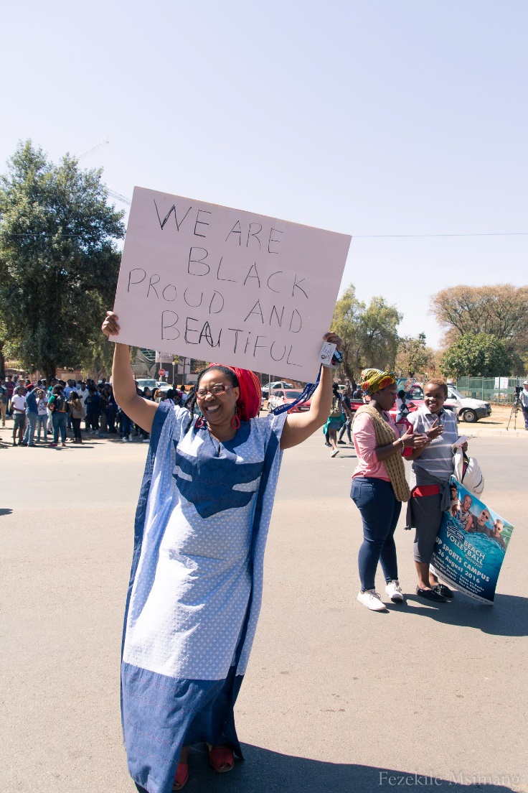
A photograph of a black woman who is a parent of a child at Pretoria High School for Girls. She is protesting the racist hair policies that the school implemented in their uniform policy. Msimang, Fezekile (2016). Pretoria.

Culturally, archetypes tend to influence reality. And while certain archetypes are experienced universally – think of the “angry black woman” or the “fiery Latina” – they will be experienced differently as tropes, because tropes are born out of a specific cultural context. Regardless, both archetypes and tropes often if not always have negative connotations, and end up encouraging existing stereotypes, especially about marginalised communities:
“In fact, even the most “positive” tropes about women of colour are harmful precisely because they dehumanize us and erase the damage that can be done to us by those who might mean well, but whose actions show that they don’t actually respect us or our right to self-determine what happens on our behalf” Mikki Kendall, Hood Feminism (2021).
Many of the archetypes and tropes about black women and our bodies have been created through a white, heteronormative, racist, capitalist and sexist lens. The same can be said for tropes of black men (because these tropes and archetypes are rooted in a white supremacist discourse whose agenda is to dehumanize black people). However, black men have access to patriarchy and misogyny, structures of power that contribute to the systemic oppression of anyone who is not a man.
In her essay on the oppositional gaze, hooks digs into how these tropes are reproduced in mass media in the context of the United States. She writes of the importance of acknowledging that mass media is a system of knowledge and power that reproduces and maintains white supremacy. And I would add that this is not only true in the United States, but anywhere that there has been a history of colonization. Thus, one can understand and recognize the dangers that come with representations of racist archetypes, as well as the necessity to critique and challenge them. Referring to audio-visual media in particular, hooks’ suggests creating spaces of agency for black people where there (can be) an interrogation and naming of the gaze of “the Other”. “The oppositional gaze” was born from hooks’ observations of the historical power dynamics involved in a look; during slavery, white slave owners punished black slaves for their gaze because to gaze was to recognise someone’s humanity and to ignore it was to assert one’s power to reinforce a white supremacist structural hierarchy. Who was and is allowed to gaze largely depended on their racial and gender identity. What intrigues me in hooks’ analysis of the gaze is that her observations lead me to realise that the development of an oppositional gaze comes from the desperate desire to control a narrative or at least attempt to.
As back people, our narrative has often been written for us in stone. It has most likely been influenced by certain archetypes and tropes shaped by a white supremacist patriarchal hierarchy, and it has often erased the complexity of our being. That being said, there were and are attempts to challenge these narratives, but sometimes these attempts end up using the same tools that were used to create them.
There is no doubt that the narratives surrounding black men or black masculine-presenting people are different from those of black women, black femmes or feminine-presenting people and queer black people. Black men bear the brunt of a legacy of their gaze being deemed dangerous, threatening, predatory and violating, which stems from a “white supremacist structure that interpreted the black male gaze as a violation and ‘rape’ of white womanhood”. Black men have also, however, had the freedom of retreating to patriarchy and the power it affords one to participate on some level of the gender hierarchy.
Black women and femmes, on the other hand, have had to retreat to create their own spaces that are void of the by-products of racist tropes, like the adultification of black girls, colourism, and the oversexualisation and fetishization of black girls and women. Like hooks, I would say that developing practices of resistance was and is a way for black people and black girls, women and femmes in particular, to shape their narrative. We have sought out to increase our representation in both the mass media and other structures of importance, like court of law and the arts, for example.
The importance of representation is bigger than just seeing a black woman character with a complex narrative on screen. Rather, I think the importance of representation lies in the acknowledgement of existence. Especially when your existence and all the complexity that comes with it has, for decades, been actively ignored and even erased.
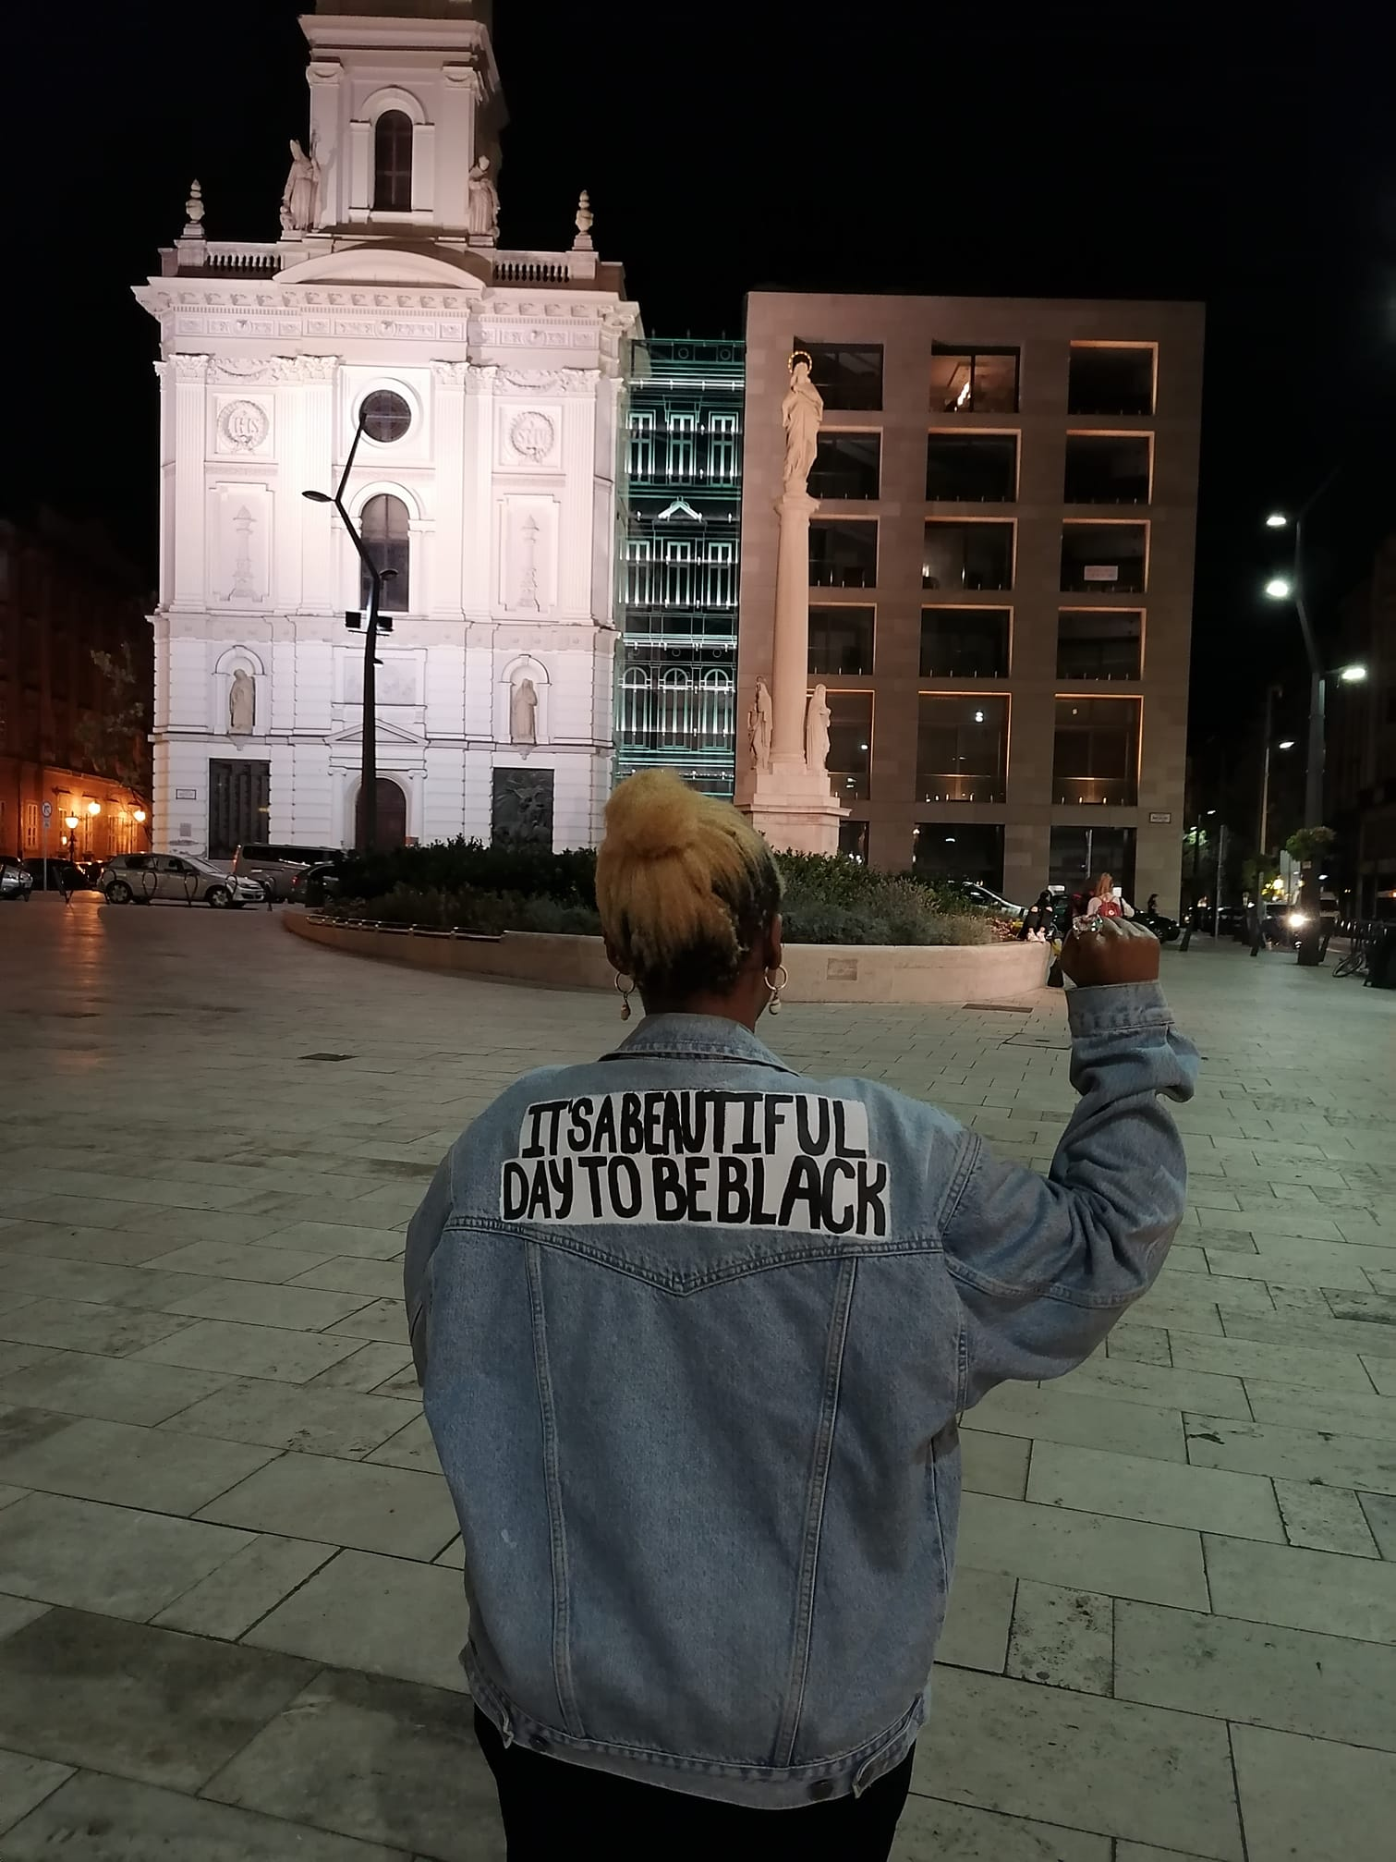
My jacket which reads: IT’S A BEAUTIFUL DAY TO BE BLACK
Kemelo Sehlapelo (2022). Budapest.
Communal Resistance as Litanies for Survival
Below are two photographs taken at different protests. The first shows a black woman with her fist raised – a powerful stance known and used by black people all over the world that represents solidarity with a cause and the people that are fighting for it. This protest happened during my second year in university. We as the student body of the university had heard about the discrimination that had happened at Pretoria High School for Girls, where there was an incident of overt racism over a teenage girl’s afro (we would soon learn that there were many more incidents relating to the “neatness” of black girls’ hair versus their white counterparts.) After our lectures, some friends of mine and I made placards and walked to the high school where we protested in solidarity with the school girls and their parents who felt like their identity was under attack under the guise of school uniform policy.
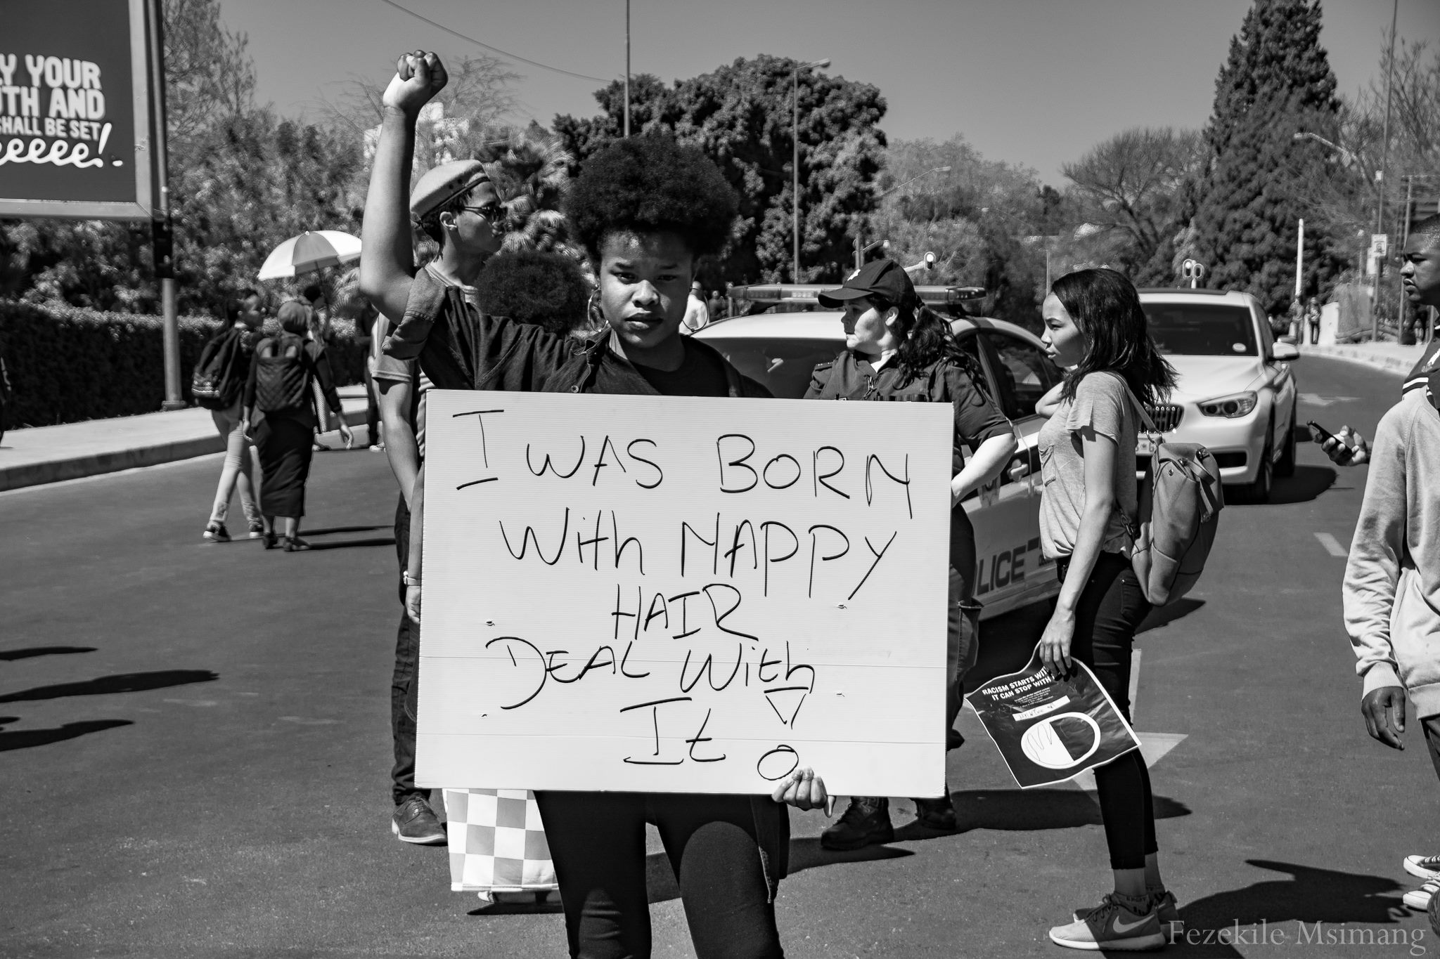
Msimang, Fezekile (2016). Pretoria.
The hair policy suggested that girls wearing afros were untidy and that their hair was not neat. They either needed to wear it in a protective style like braids (although nothing too ‘extravagant’) or have it relaxed (meaning, to put a dangerous chemical that straightens the hair for a period but has negative and long-lasting health implications for users).
Policies like these were not uncommon in schools in South Africa. Nor do they stop showing their faces in spaces outside of a school context. But what will similarly never stop is the tenacity and strength of black women to keep showing up for each other, and “daring to be powerful”.
What happens at protests is something that can only be described as the magic that comes from collective resistance. As a form of resistance, it encompasses solidarity, community and shows the power of being heard. Black people have used voice, song and dance for centuries in many different contexts, and protests are no different. In South Africa, the use of song, dance and even performance as protest art have been powerful vectors of making ourselves seen and heard.

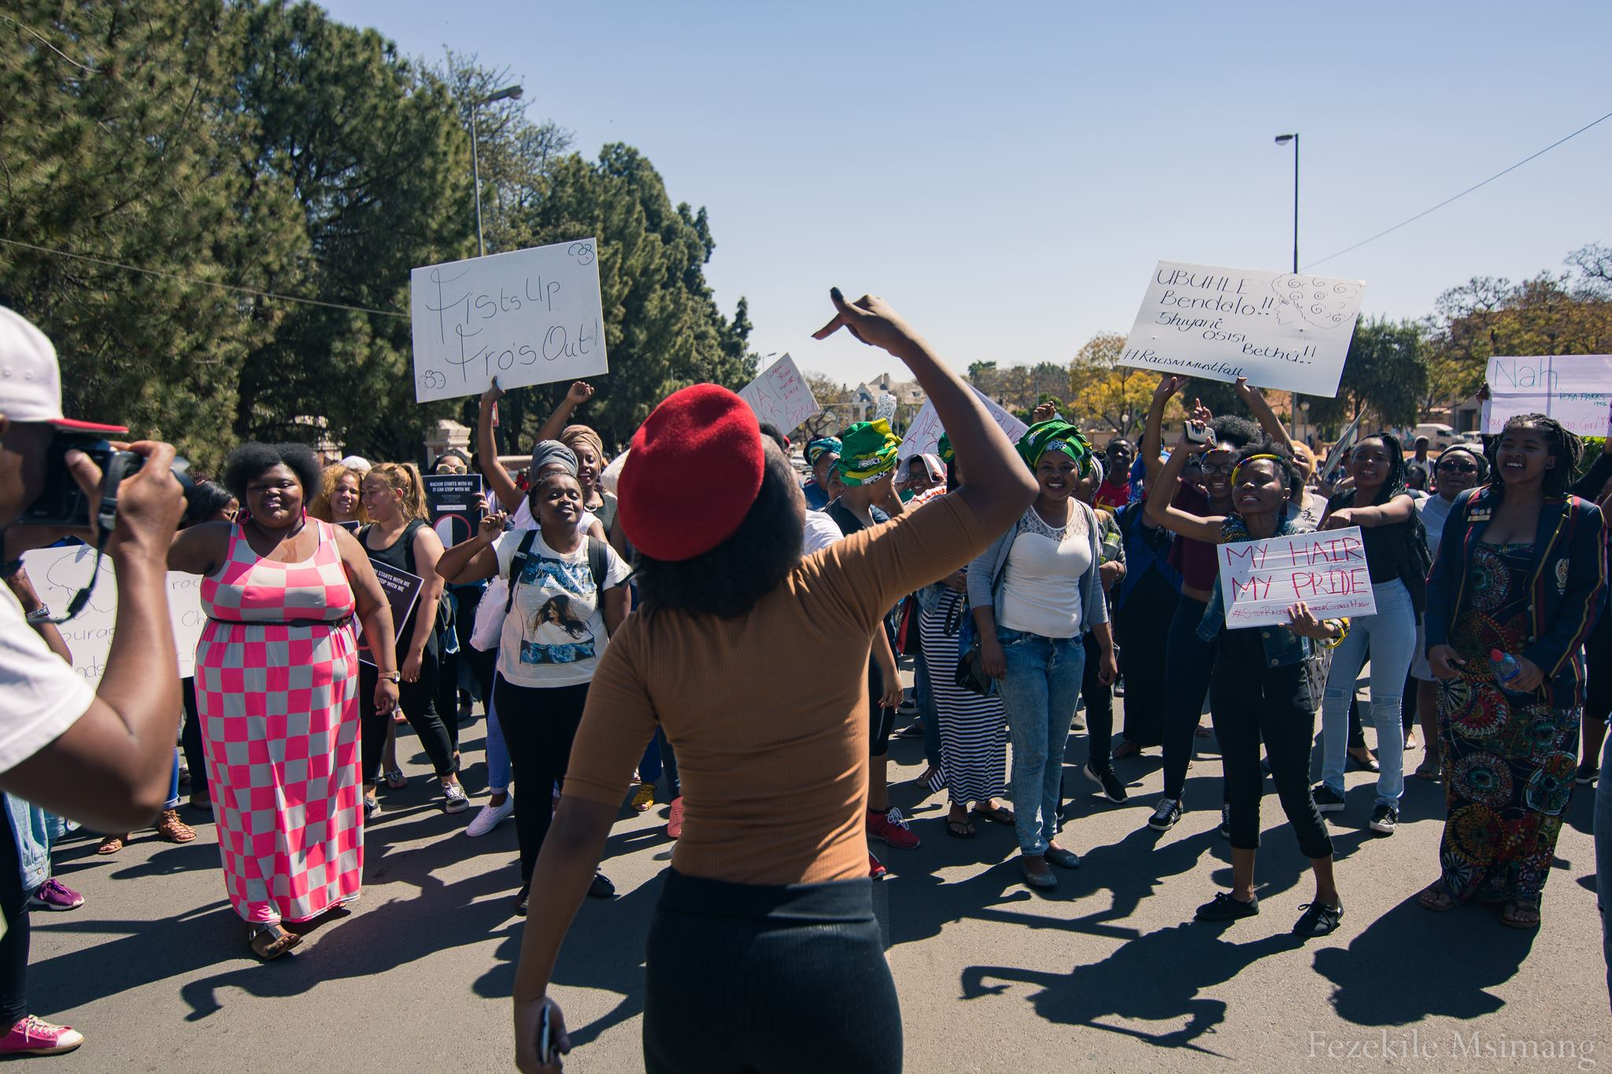
A powerful image of a black woman leading a chorus of protestors in song.
Msimang, Fezekile (2016). Pretoria.
In the spirit of Audre Lorde’s poem “A Litany for Survival”, I believe that just like there is a chorus of people in this photograph above singing and chanting and taking up space, so too must our practices of resistance be loud – in that they take up space – and collective. There must be a willingness to approach the painful intergenerational histories of trauma with gentleness and care and to remember and celebrate the audacious nature of black people to find joy even in the darkest of moments. As an artist, drawing upon these sacred memories and histories is my greatest honour. To learn from the wisdom of teachers like bell hooks, and Audre Lorde, and authors and artists similar to them, is to educate ourselves towards liberation and to honour our collective memories.
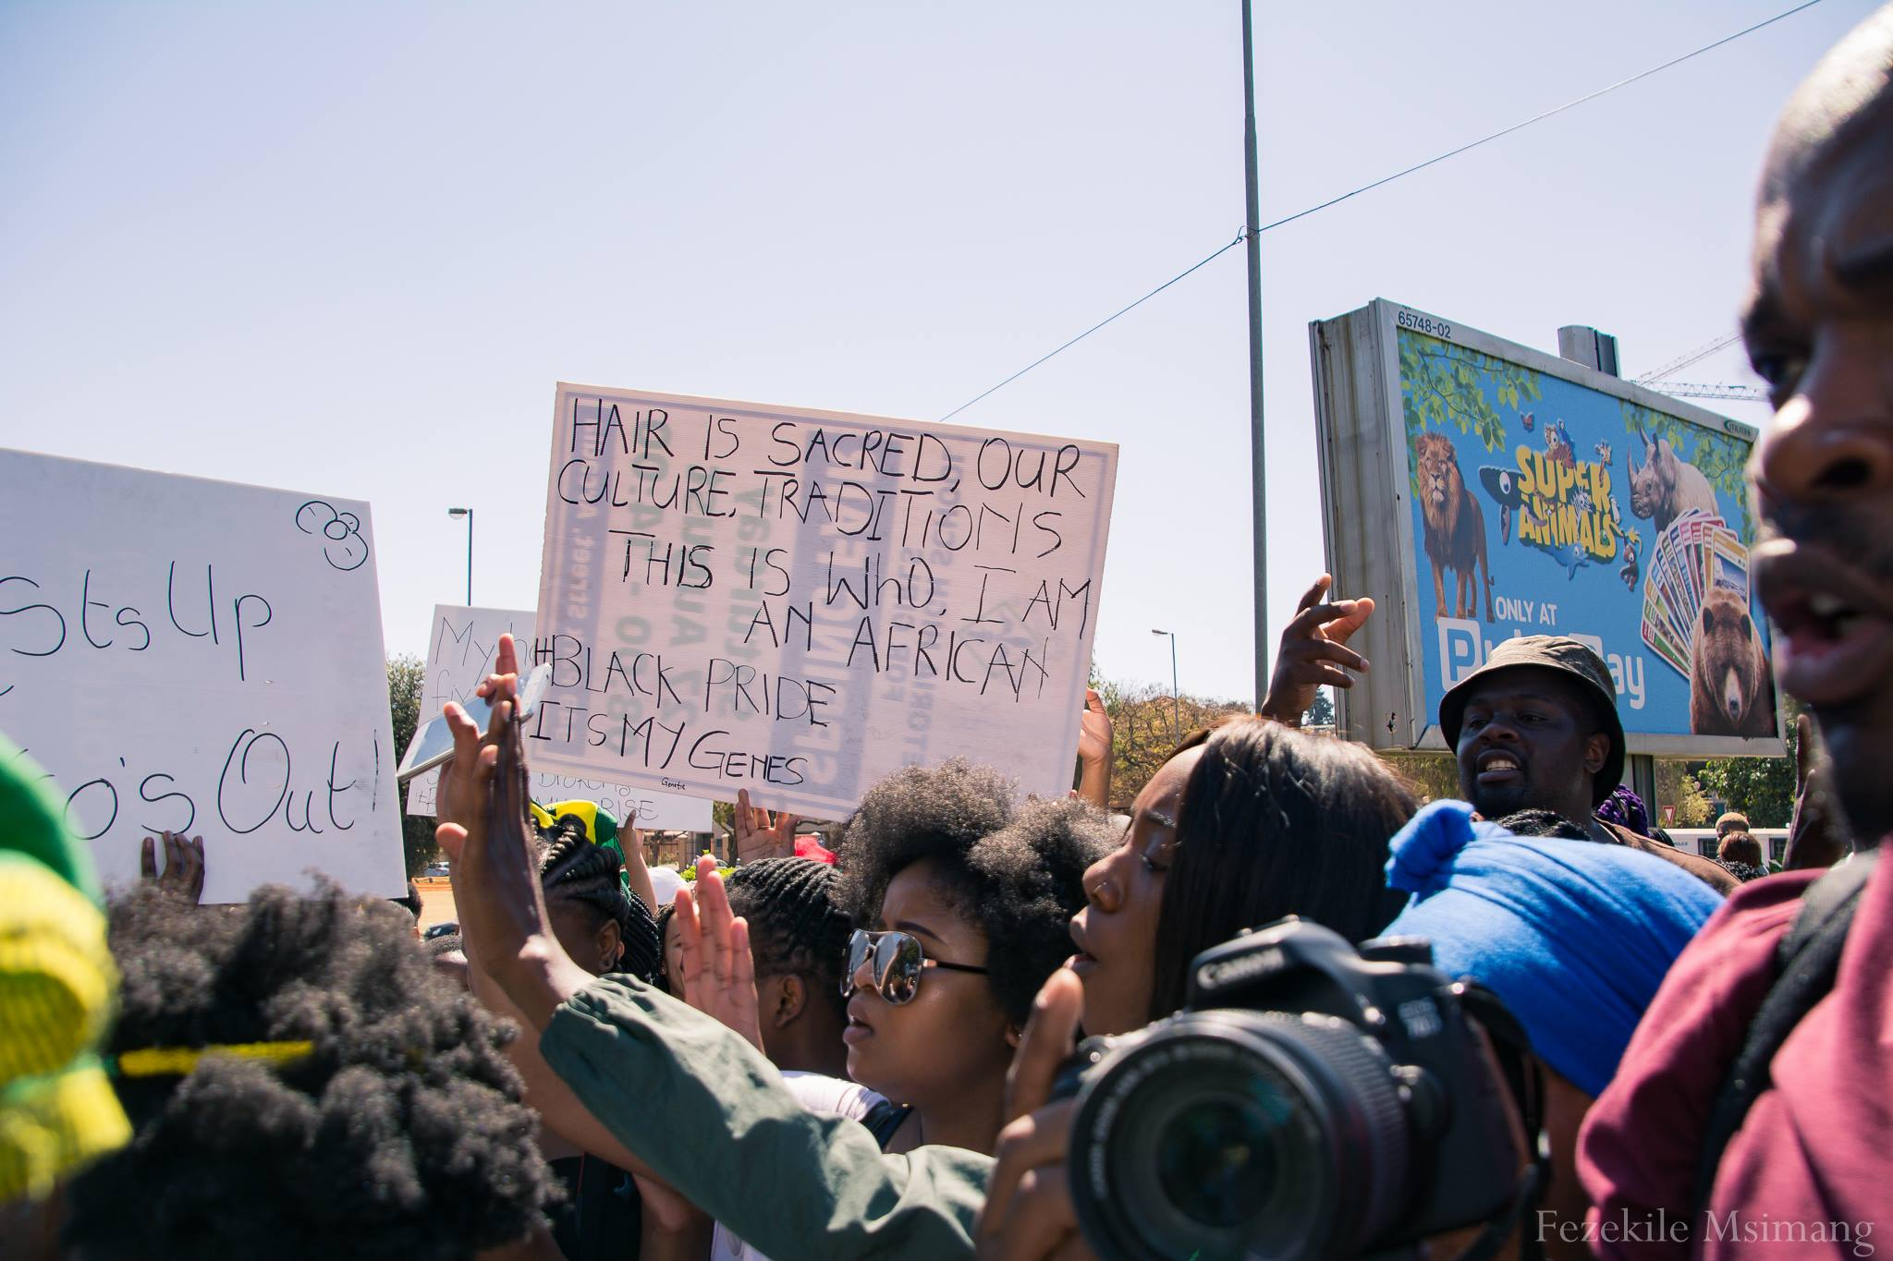
A placard at the protest at Pretoria High School for Girls reads: “Hair is sacred, our culture, traditions. This is who I am. An African. #BlackPride #ItsInMyGenes.
Msimang, Fezekile (2016). Pretoria.

Works Cited
hooks, bell. (2015 [1989]). Preface, “Introduction: Some Opening Remarks,” and “Talking Back.” Talking Back: Thinking Feminist, Thinking Black. New York: Routledge. ix-xi, 1-4, 5-9. PDF.
hooks, bell (1992). “The Oppositional Gaze: Black Female Spectator.” The Feminism and Visual Cultural Reader. Ed. Amelia Jones. New York: Routledge. 94–105. PDF.
hooks, bell. (2010). Teaching Critical Thinking.
Kendall, M. (2021c). Hood Feminism: Notes from the Women White Feminists Forgot. Bloomsbury Publishing.
Lorde, A. (2020). When I Dare to Be Powerful.

